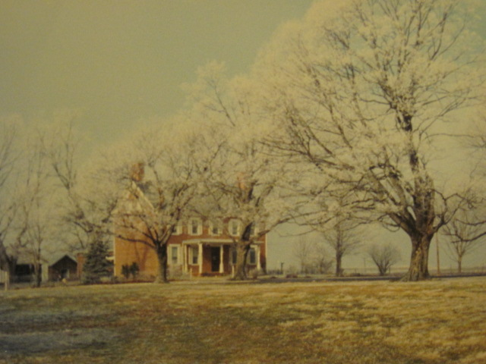

Luther & Dorothy Wolfe List home

Taken on an icy winter morning probably in the 1960’s

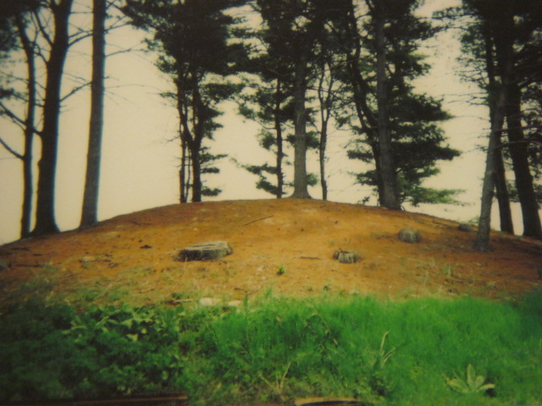

The Adena Indian Burial Mound on the Luther and Dorothy List farm – about 1960s